LAB ACTIVITY (Exp-2&3)
- Create a linked list by taking input from the user.
- Find the middle of the linked list without using the length function.
- Perform the deletion operation at the beginning of the linked list
#include <stdio.h>
#include <stdlib.h>

typedef struct Node {
int data;
struct Node* next;
} node;

node* head = NULL;

void createnode() {
node *q, *temp;
temp = (node*)malloc(sizeof(node));
printf("Enter data:");
scanf("%d", &temp->data);
temp->next = NULL;

if (head == NULL) {
head = temp;
} else {
q = head;
while (q->next != NULL) {
q = q->next;
}
q->next = temp;
}
}

void display(node* h) {
int k=1;
while (h != NULL) {
printf("Data %d: %d\n", k, h->data);
h = h->next;
k++;
}
}

void displayMiddle(node *head){
node *slow,*fast;
slow=fast=head;
if(head==NULL){
printf("The list is empty");
}
while(fast!=NULL && fast->next!=NULL){
fast=fast->next->next;
slow=slow->next;
}
printf("\nMiddle data:%d",slow->data);
}

node* deleteatBegin(node *head){
if (head == NULL) {
printf("\nList is already empty!\n");
return NULL;
}
node *temp = head;
head = head->next;
free(temp);
return head;
}

int main() {
int n, i;
printf("Enter the number of nodes: ");
scanf("%d", &n);

for (i = 0; i < n; i++) {
createnode();
}

printf("Linked list contents:\n");
display(head);
displayMiddle(head);
head = deleteatBegin(head);
printf("\nNew list after deletion at the beginning:\n");
display(head);

return 0;
}

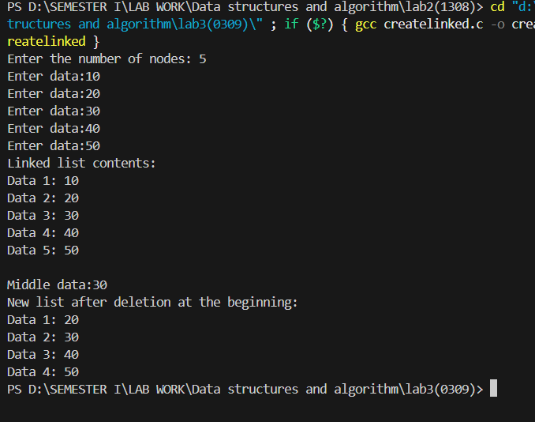

Reverse a linked list
  - Entire linked list
  - Reversing the linked list using given positions of start and stop

#include <stdio.h>
#include <stdlib.h>

typedef struct Node {
int data;
struct Node* next;
} node;

node* head = NULL;

void createnode() {
node *q, *temp;
temp = (node*)malloc(sizeof(node));
printf("Enter data:");
scanf("%d", &temp->data);
temp->next = NULL;

if (head == NULL) {
head = temp;
} else {
q = head;
while (q->next != NULL) {
q = q->next;
}
q->next = temp;
}
}

void display(node* h) {
int k=1;
while (h != NULL) {
printf("Data %d: %d\n", k, h->data);
h = h->next;
k++;
}
}

node * reverseLinkedList(node *head){
node *pnode, *cnode, *nnode;
pnode=nnode=NULL;
cnode=head;
while(cnode)
{
nnode=cnode->next;
cnode->next=pnode;
pnode=cnode;
cnode=nnode;
}
return pnode;
}

node* reverseLinkedListPos(node* head, int m, int n) {
node *pnode = NULL, *cnode = head, *nnode = NULL;
node *tempnode1 = NULL, *tempnode2 = NULL;
int k = 1;

if (m == 1) {
tempnode1 = NULL;
tempnode2 = cnode;
} else {
while (k < m) {
tempnode1 = cnode;
cnode = cnode->next;
k++;
}
tempnode2 = cnode;
}

pnode = NULL;
while (cnode && m <= n) {
nnode = cnode->next;
cnode->next = pnode;
pnode = cnode;
cnode = nnode;
m++;
}

if (tempnode1)
tempnode1->next = pnode;
else
head = pnode;

tempnode2->next = cnode;

return head;
}

int main() {
int n, i;
printf("Enter the number of nodes: ");
scanf("%d", &n);

for (i = 0; i < n; i++) {
createnode();
}

printf("Linked list contents:\n");
display(head);

head=reverseLinkedList(head);
printf("Reversed Linked List:\n");
display(head);

int m, o;
printf("Enter the positions you want to reverse the Linked List:");
scanf("%d %d",&m,&o);
head=reverseLinkedListPos(head, m ,o);
printf("Reversed Linked List:\n");
display(head);

return 0;
}

